**News Feed**

News Feed is a web application developed using Flask and newsapi. The application will be used to extract top news articles based on certain queries.

**REQUEST**

Request to the api will be sent as a form data. The form uses POST method. The form data should contain three values

* Country
* Category
* SUBMIT

In country section, the user will enter the country name. In category section, the user will enter a category based on which he/she want to perform the search operation. The SUBMIT is a value from the button denoting that the button was clicked.

The request will be sent to the application as a form-data which is ImmutableMultiDict object.

For example, If the user want to extract URLs of articles that were based on India and category as Vaccine, then the request will be sent as :

**ImmutableMultiDict([(‘country’,’india’),(‘category’,’vaccine’),(‘submit’,’SUBMIT’)])**

**Response**

The response sent will be a JSON file which contains the extracted links based on the user request. The request links were sorted by relevancy so, the most relevant information will be displayed first. The response contains the JSON file in the format:

{

“url”:[

List of URLs extracted based on the queries

]

}

**For example**, If the request was sent as : ImmutableMultiDict([(‘country’,’india’),(‘category’,’vaccine’),(‘submit’,’SUBMIT’)])

The response will be :

{"url": ["https://timesofindia.indiatimes.com/india/in-vaccine-hunt-no-tactic-leftuntried/articleshow/75530832.cms", "https://timesofindia.indiatimes.com/life-style/healthfitness/health-news/italy-claims-to-develop-first-covid-19-vaccine-here-is-the-current-status-of-allthe-potential-coronavirus-vaccines/photostory/75575319.cms", "https://timesofindia.indiatimes.com/life-style/health-fitness/health-news/immunity-boosting-aavaalkaline-water-extends-helping-hand-during-the-current-health-crisis/articleshow/76040820.cms", "https://timesofindia.indiatimes.com/world/europe/there-may-never-be-a-covid-19-vaccine-whocoronavirus-expert/articleshow/75526635.cms", "https://economictimes.indiatimes.com/industry/tech/ai-can-help-doctors-governments-fightcovid-19-pandemic/articleshow/75977713.cms", "https://timesofindia.indiatimes.com/lifestyle/health-fitness/health-news/coronavirus-vaccine-latest-news-update-after-moderna-chinesecovid-19-vaccine-shows-promising-results-enters-the-human-trialphase/articleshow/75942911.cms", "https://timesofindia.indiatimes.com/life-style/healthfitness/health-news/coronavirus-vaccine-latest-news-covid-19-vaccine-status-update-these-4coronavirus-vaccines-are-leading-the-race/photostory/75670744.cms", "https://timesofindia.indiatimes.com/life-style/health-fitness/health-news/coronavirus-vaccinecovid-19-news-china-conducts-first-successful-coronavirus-vaccine-test-onmonkeys/articleshow/75644778.cms", "https://timesofindia.indiatimes.com/life-style/healthfitness/health-news/coronavirus-vaccine-current-update-covid-19-vaccines-drugs-latest-newsoxford-vaccine-failure-to-modernas-favourable-results-here-is-the-latest-status-of-covid-19vaccines-and-drugs/photostory/75872351.cms", "https://timesofindia.indiatimes.com/world/us/trump-says-us-to-have-coronavirus-vaccine-by-endof-year/articleshow/75525107.cms", "https://timesofindia.indiatimes.com/life-style/healthfitness/health-news/coronavirus-treatment-news-covid-19-cure-and-vaccine-latest-update-fromleprosy-drug-to-hiv-drug-list-of-drugs-that-are-being-studied-as-effective-covid-19treatment/articleshow/75729782.cms", "https://timesofindia.indiatimes.com/life-style/healthfitness/home-remedies/covid-19-ministry-of-ayush-starts-clinical-trials-for-ashwagandha-and-4other-ayurvedic-herbs-here-is-what-you-need-to-know/photostory/75692669.cms"]}

**Deployment :**

The application was deployed as a docker container. The docker container Images can be found in the link :

<https://hub.docker.com/repository/docker/vignesh1999/news-feed-app>

**Request Object:**

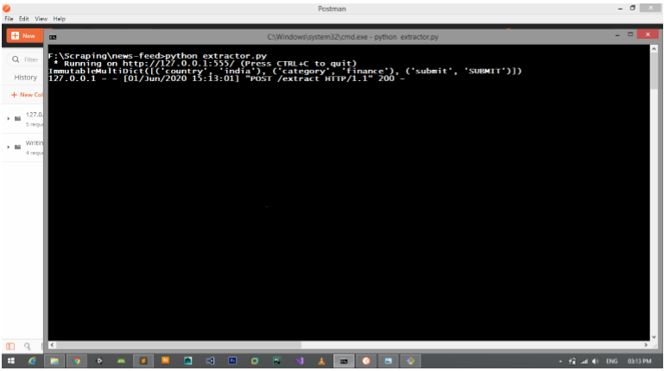

**Front End**

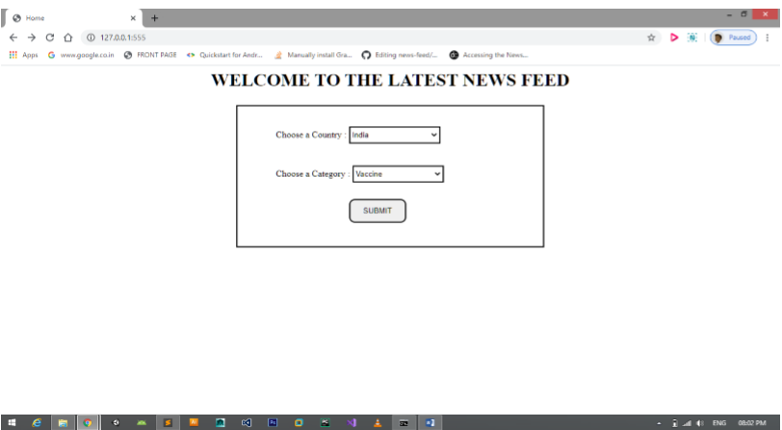

**Response And request:**

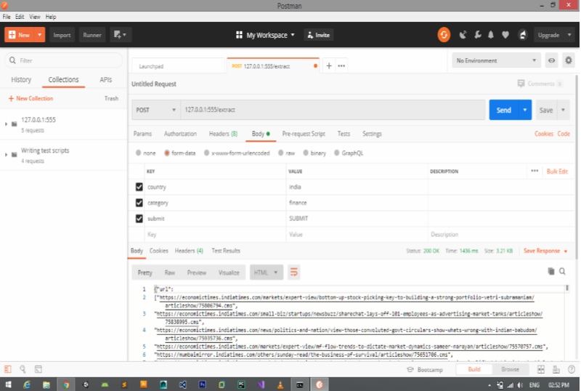

**The Request is received from the chatbot team in this format:**

{  
"country":"country_name"  
"category":"category_name"  
}

The API takes in the country name and category, extracts the news using the NEWS API. Sentiment analysis is done on the extracted news. Different categories of news like crime rates, vaccines, hospitals etc are available in this API. The API extracts the recent top news form the top newspaper articles in that location. The designed scheduler updates the news every 6 hrs since the number of requests is limited to 500 per day. However, multiple NewsApi keys are used to handle this. Once the number of Requests for crosses its limit, the next API key will be used to extract the news.

**News.csv file:**



The data gets updated in this format. The sentiment score of the news is also added in the output news.csv file.

**Postman Request:**

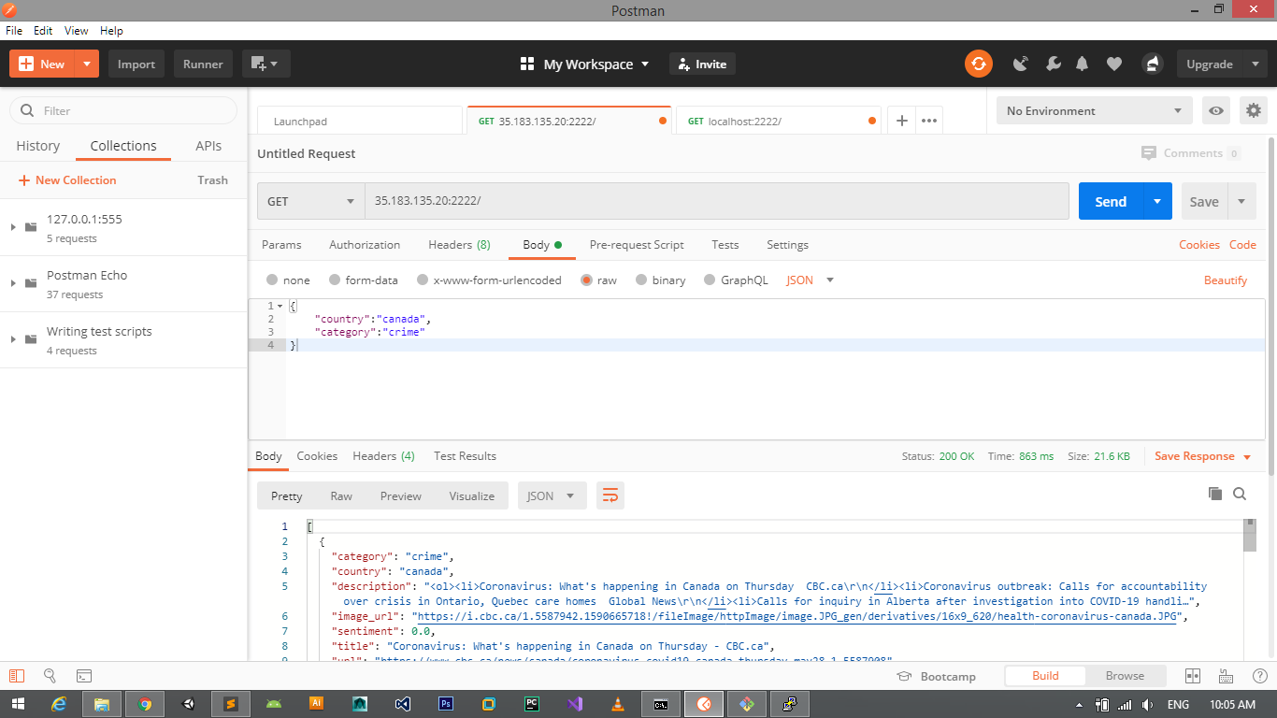

The news API is limited to country level. All the API to extract the news are limited to country level.

**Links:**

NewsApi: <https://newsapi.org/>